**Object Oriented Programming (BSE-3A & BCS-3H)**

**Assignment 4 - Complex Numbers**

Implement following **ComplexNumber** class and write driver program to produce given sample output:

class ComplexNumber

{

private:

int real;

int imaginary;

public:

ComplexNumber(int, int); //with default arguments

~ComplexNumber(); //Does Nothing.

void Input();

void Output();

bool IsEqual(ComplexNumber);

ComplexNumber Conjugate();

ComplexNumber Add(ComplexNumber);

ComplexNumber Subtract(ComplexNumber);

ComplexNumber Multiplication(ComplexNumber);

float Magnitude();

};

**Sample Output:**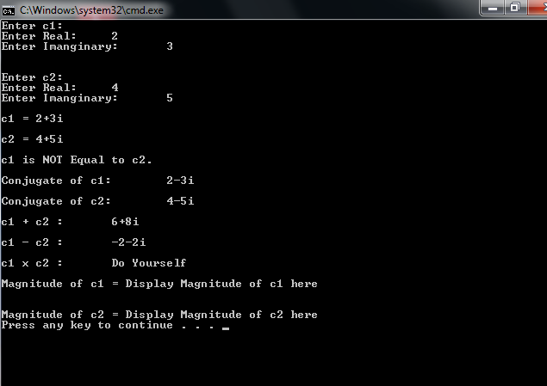

**Help:**

<https://en.wikipedia.org/wiki/Complex_number>

**Important:**

* Do not change class definition
* Submit only one **RUNNING** file YourRollNumber.cpp that contains class, its implementation and the driver Program. Do not submit .rar or .zip files.